# 2.1 Introduction to analysis

**Analysis** is the process of breaking a complex topic or substance into smaller parts in order to gain a better understanding of it. The technique has been applied in the study of mathematics and logic since before Aristotle though **analysis** as a formal concept is a relatively recent development. It is the systematic study of real and complex-valued continuous functions.

In my project I have also done analysis to better understand. It helps a lot in my project.

## Activities are involved in analysis

The objective of this phase is to define in more detail the system inputs, processes, output and interfaces. Unless specifically constrained by the project charter, requirements. Analysis should not consider the computer programs, files and data streams.

Requirements Analysis will identify and consider the risks related to how the technology will be integrated into the standard operating procedures. Requirements Analysis will collect the functional and system requirements of the business process, the user requirements and the operational requirements (e.g., when operational what is necessary to keep the system up and running).

## Need for analysis

The opinion of end users is essential to unify a diverse, opinionated design team, and their opinion should transcend the desires of your design team. Market research is essential to unify end user opinions, and to use quantitative and qualitative research to find the best direction for product or service designs. Continue to monitor user feedback after the product launch, and address defects quickly and keep an accurate record to apply to future releases, if they cannot be addressed immediately in the current product. In my project I used CATWOE analysis because It helps to know the about the world and many more.

## CATWOE Analysis

C: Customers

A: Actors

T: Transforming

W: **World view**

**O: Owner**

**E: Environment**

**CATWOE Analysis is a technique for understanding a stakeholder's perspective and the impact that this view will have on the direction of the business change. I used the CATWOE in my project because** Usually business stakeholders will have ideas about the direction the organization should take, the requirements to be addressed, the options for improvement and the solutions that should be implemented. This helps know the world what is happening and many more.

# 2.2 Feasibility Study

A feasibility study includes an estimate of the level of expertise required for a project and who can provide it, quantitative and qualitative assessments of other essential resources, identification of critical points, a general timetable, and a general cost estimate.

whether a project is viable or not, i.e. whether it can generate an equal or a higher rate of return during its lifetime requires a thorough investigation of the investment per se as well as the level of current expenditure.

In my project, Online Food Ordering System I have used this feasibility study because it helps a lot in different way. There are many feasibility study and I have explained in below.

## Types of feasibility study:

* Economic feasibility

In my project It helps to Validating that a goal is possible within financial constraints. For example, a construction project that uses reference class forecasting as a sanity check for project budget. In my project this feasibility helps to do the work within a given financial amount.

* Technical feasibility

Technical feasibility helps in technical part in my project to collect requirements. For example, an ecommerce project confirms that a partner's API can support a list of requirements for an integration project. This project is in technical way. so, it helps a lot.

* Schedule feasibility

Validating that a goal is possible with time constraints. This feasibility helps to end the work in given time and distribute the item in time. It helps to check and see the product in time or not.

* Operational feasibility

The feasibility of deploying and operating a project. For example, the costs and technical challenges associated with operating and maintaining a deep water offshore wind farm.

* Legal feasibility

This feasibility helps to know the legal and ethical requirements. In my project, this helps to know about the copyrights or not your project and it is safety or not and can know about the tax number and many more.

# 2.3 Requirement Analysis

Requirements analysis is critical to the success or failure of a systems or software project.The requirements should be documented, actionable, measurable, testable, traceable, related to identified business needs or opportunities, and defined to a level of detail sufficient for system design.

## Functional Requirements

The Functional Requirements Specification documents the operations and activities that a system must be able to perform.

Functional Requirements should include:

* Descriptions of data to be entered into the system
* Descriptions of operations performed by each screen
* Descriptions of work-flows performed by the system
* Descriptions of system reports or other outputs

The Functional Requirements Specification is designed to be read by a general audience. Readers should understand the system, but no particular technical knowledge should be required to understand the document.

The functional requirements are:

1. Login
2. Registration
3. Menu
4. forum
5. place an order
6. Add, delete, update item
7. Receive for confirmation

|  |  |
| --- | --- |
| Functional Requirements ID | Title |
| F1 | Login |
| F2 | Registration |
| F3 | Menu |
| F4 | forum |
| F5 | place an order |
| F6 | Add, delete, update |
| F7 | Receive for confirmation |

## Non-functional Requirements

Nonfunctional Requirements define system attributes such as security, reliability, performance, maintainability, scalability, and usability etc. They serve as constraints or restrictions on the design of the system across the different backlogs.

1. Usability

Usability is the ease of use and learnability of a human-made object. In Software engineering, usability is the degree to which a software can be used by specified consumers to achieve quantified objectives with effectiveness, efficiency, and satisfaction in a quantified context of use.

1. Reliability

The ability of an item to perform a required function under stated conditions for a specified period of time.

1. portability

portability in high-level computer programming is the usability of the same software in different environments. The pre requirement for portability is the generalized abstraction between the application logic and system interfaces. When software with the same functionality is produced for several computing platforms, portability is the key issue for development cost reduction.

1. validation

Validation is the process of establishing documentary evidence demonstrating that a procedure, process, or activity carried out in testing and then production maintains the desired level of compliance at all stages. It is very important for industry for final testing. Qualification of systems and equipment is therefore a part of the process of validation.

1. Browsers support

**Browser** **support**. **Browser** **support** varies for each version of the user interface (UI). Most major **browsers** are **supported**. Note: Some features have additional **browser** requirements, which are noted in the appropriate documentation.

1. Security

Every website must Security. It is very important in every system. If there is no security, then there are many risks in our website. So, there must be security in every website.

|  |  |  |
| --- | --- | --- |
| ID | Non- functional Requirement Title |  |
| NFR1 | Usability |  |
| NFR2 | Reliability |  |
| NFR3 | portability |  |
| NFR4 | validation |  |
| NFR5 | Browsers support |  |
| NFR6 | Security |  |

## Moscow prioritization

M: Must have

S: Should have

C: Could have

W: Won't have

The MosCow method is a prioritization technique used in management, business analysis, project management, and software development to reach a common understanding with stakeholders on the importance they place on the delivery of each requirement-also known as MoSCoW prioritization or Moscow analysis.

|  |  |  |
| --- | --- | --- |
| ID | Title | Moscow |
| FR1 | Login | Must have |
| FR2 | Registration | Must have |
| FR3 | Menu | Must have |
| FR4 | Online chat | Won't have |
| FR5 | Comment | Could have |
| FR6 | Add, Remove, Update item | Must have |
| FR7 | Review Order | Should have |
| FR8 | Receive for confirmation | Must have |
| FR9 | Logout | Must have |
| FR10 | Internet | Must have |

Non-functional Requirement

|  |  |  |
| --- | --- | --- |
| ID | Title | MosCow |
| NFR1 | Usability | should have |
| NFR2 | Reliability | should have |
| NFR3 | portability | could have |
| NFR4 | validation | Must have |
| NFR5 | Browsers support | Must have |
| NFR6 | Security | Must have |

## Software requirement specification

A software requirements specification (SRS) is a description of a software system to be developed. It lays out functional and non-functional requirements, and may include a set of use cases that describe user interactions that the software must provide.

**Software Requirement**

**Programming language:** PHP

**Database:** My SQL

**UI Design:** HTML, CSS

**Web Brower:** Chrome, opera, Mozilla

**Software used:** XAMPP server

**Hardware Requirement**

Memory: 4GB RAM

Storage: 1 GB

OS: Windows 10 64 bits

## System Architecture

A 3-tier architecture is a type of software architecture which is composed of three “tiers” or “layers” of logical computing. They are often used in applications as a specific type of client-server system. 3-tier architectures provide many benefits for production and development environments by modularizing the user interface, business logic, and data storage layers.

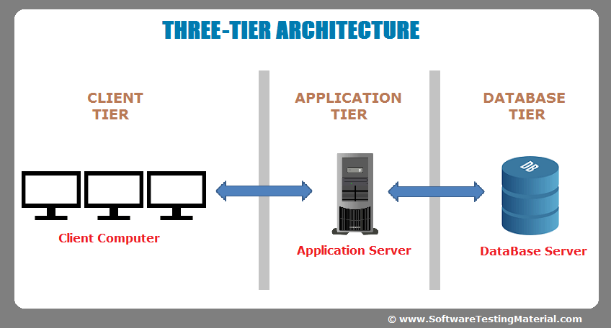

Figure 1: A 3-tier architecture

## Use case Diagram

The process analysis system requirement is to develop a project is use case. It interaction between user and system in a particular environment. It helps to manage functional requirement. Record the interaction between user and system.

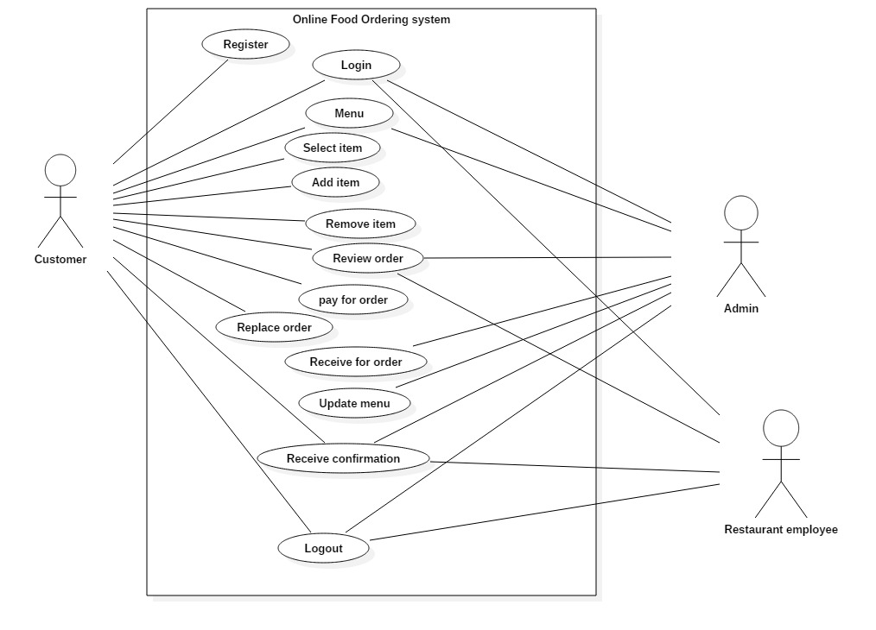

Figure 2: Use case diagram of online food ordering system

## Initial class diagram

A class diagram is a type of diagram and part of a unified modeling language(UML) that defines and provides the overview and structure of a system in terms of classes, attributes and methods, and the relationships between different classes.

Natural Language Analysis

|  |  |
| --- | --- |
| Nouns | verbs |
| Restaurant, place, food, order, employee, customer, admin, delivery, book, place, user, name, time, user, problem, responsible, | Add, Update, Remove, review, register, login, find, details, store, notify, prepare, mention, select, confirmation |

Final candidate classes(noun) are

Admin, customer, order, employee

Final candidate classes(verbs):

Add, update, login, details, review, remove, delete, select, confirmation

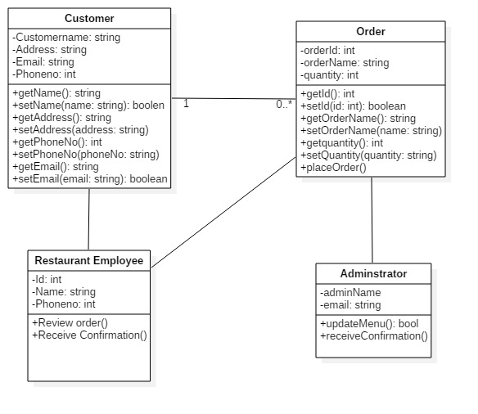

Figure 3:class diagram

# Conclusion

Finally, I have completed the analysis. In this system user should allow to browse through different products. It saves time a lot and can view the details information about the order. In this project I have used PHP for programming language, software XAMPP server and MySQL for database. User should allow review the order, see the menu list, remove, add and many more.

# Bibliography

Anon., 1999. *natural language analysis.* [Online]   
Available at: www.contrib.andrew.cmu.edu/~dyafei/NLP.html  
[Accessed 24 april 2019].

Anon., 2000. *online food ordering.* [Online]   
Available at: https://creately.com/diagram/example/ieid5fhz1  
[Accessed 20 april 2019].

Anon., 2005. *online food ordering system - PHP MySQL project.* [Online]   
Available at: https://www.freeprojectz.com/paid-projects/php-mysql/online-food-ordering-system  
[Accessed 1 may 2019].